Task: Media Message Deconstruction

Keeping in mind the five Key Questions and five Core Concepts of Media Literacy, choose a piece of media relating to nutrition or health – this could be a print ad, a billboard, a commercial, etc – and break it down to reveal any misrepresentations, embedded values and persuasion techniques that it contains.

The finished product of your analysis can be either a written piece, or you may creatively reimagine the media to highlight its hidden messages or inaccuracies using Photoshop or another artistic medium.

Example:

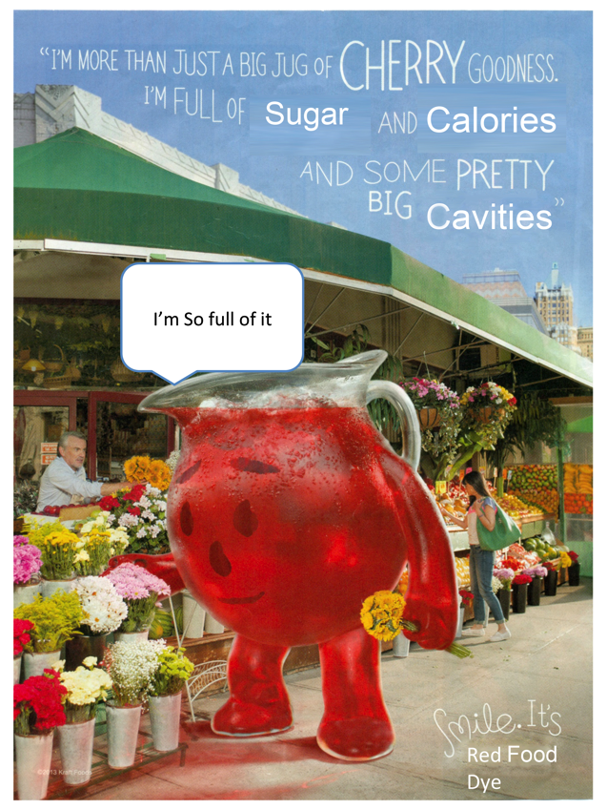

(Lots more examples available at: https://medialiteracyproject.org/deconstructions/)

In evaluating your work, we will be looking for:

An understanding of the goals, points of view and persuasion techniques
used by the original creators of your chosen media message
Use of your expertise in nutrition and health to evaluate the claims and
assumptions made in your media piece. This may mean looking up nutrition facts or researching claims made about specific ingredients.

If you need help with finding information or with developing your finished product, please come see me in the library!

Due: October 19th – Please turn in to Ms. Geist, we will be grading jointly!

